How to install a Vinyl Sticker
Step 1:
Clean surface and remove any dirt, oils before attaching decal. Place decal on a hard smooth surface (front side of decal facing up). Tape and secure the top of decal to surface. DO NOT remove clear transfer tape.
Step 2:
Using a credit card squeegee (burnish) the entire decal surface. Apply medium pressure to burnish decal surface. DO NOT remove clear transfer tape.
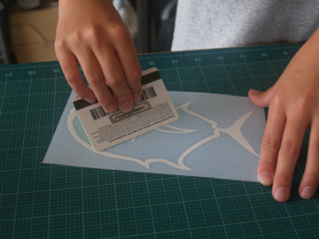
Step 3:
Apply a strip of masking tape to the top of the decal. Position the masking tape half way on the clear transfer tape and half off. The masking tape that is off the transfer tape will be used to secure and position the decal on your window.
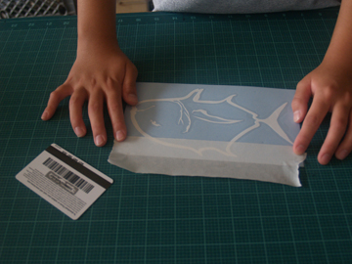
Step 4:
Attach and secure masking tape and decal to window for placement.
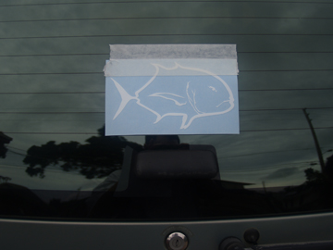
Step 5:
Using a credit card, evenly squeegee the decal from the top pushing the decal down to the surface moving from right to left. This is to make sure that the decal will stick to the clear transfer tape.
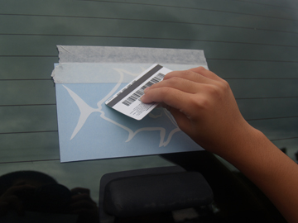
Step 6:
Carefully peel off the bottom corner of the clear transfer tape and hold down the blue backing. (IMPORTANT: Make sure the entire white decal is attached to the clear transfer tape. If the decal is not attached to the clear transfer tape gently push it back onto the blue backing and re squeegee with medium pressure, only the area that is not adhering to the clear transfer tape and try lifting again.)
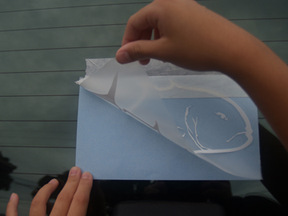 | 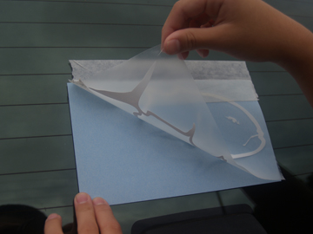
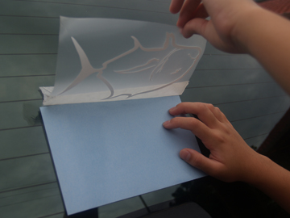 | 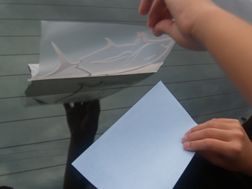  *Discard blue backing.
Step 7:
Squeegee the entire decal surface to the window to allow proper adhesion to surface. Start from the top of the decal design and evenly squeegee in a downward motion from left to right all the way to the bottom of the decal.

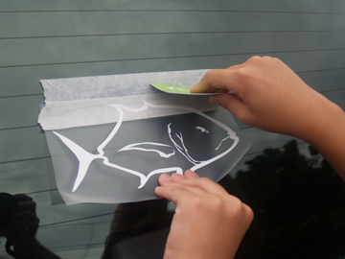 | 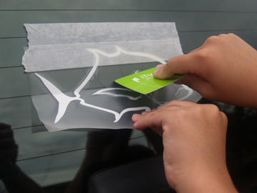
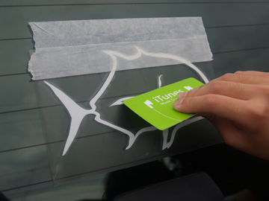
Step 8:
Carefully peel back the clear transfer tape, pulling down at a 45 degree angle. The decal should adhere to the window. If the decal adheres to the clear transfer tape replace the decal back on the surface and squeegee the edges of the decal again. Repeat if necessary
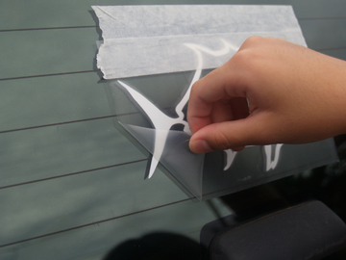 | 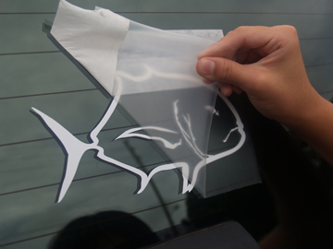
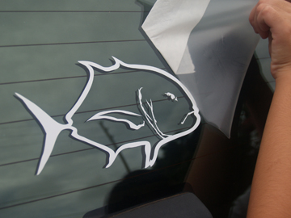 | 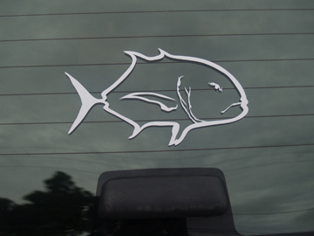  All Pau! (Finish)
Tip : To remove any air bubbles under the decals after you have applied the decal to your window, use a sewing needle, puncture the bubble and gently push the air bubble towards the hole with your finger

